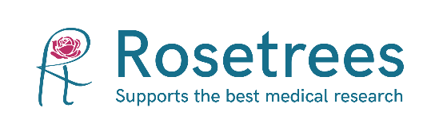

**Summer 2025 internship opportunity**

An exciting opportunity for an undergraduate to work with the Rosetrees team from June 2025 for up to ten weeks. Potential candidates must have completed at least one year of a STEM degree and have an interest in biomedical research.

Rosetrees is a private UK charity that has been funding cutting edge medical research since 1990. Our aim is to improve the health and wellbeing of society.

Currently, around 300 projects are supported, from seedcorn 'out of the box' research ideas to large awards. Our focus is testing new ideas across the spectrum of medical research to bring the earliest patient benefit.

This is a challenging and worthwhile opportunity to gain an insight and experience working in medical research, working alongside our friendly and enthusiastic team.

Examples of tasks will include participating in meetings with Rosetrees-funded researchers and producing meeting reports.

* Compiling reports evaluating the progress and impact of Rosetrees-funded projects.
* Supporting the grant management team in the grant review process.
* Attending weekly team meetings.
* Identifying potential reviewers for grant applications.
* Helping to prepare project updates for partner funders.
* Summarising documents and articles for the team.

To apply for this role, please send an expression of interest together with a copy of your CV to:

Megan Sealey-Bright PhD

Research and Communications Officer Rosetrees

Email: **mbright@rosetrees.org.uk**